VISVESVARAYA TECHNOLOGICAL UNIVERSITY
“JnanaSangama”, Belgaum -590014, Karnataka.


LAB REPORT
On
OPERATING SYSTEMS (23CS4PCOPS)

Submitted by
Pratham Khatwani (1BF24CS228)

in partial fulfillment for the award of the degree of
BACHELOR OF ENGINEERING
in
COMPUTER SCIENCE AND ENGINEERING



B.M.S. COLLEGE OF ENGINEERING
(Autonomous Institution under VTU)
BENGALURU-560019
February to June 2026

B. M. S. College of Engineering,
Bull Temple Road, Bangalore 560019
(Affiliated To Visvesvaraya Technological University, Belgaum)
Department of Computer Science and Engineering



CERTIFICATE

This is to certify that the Lab work entitled “OPERATING SYSTEMS” carried out by Pratham Khatwani(1BF24C228), who is a bonafide student of B. M. S. College of Engineering. It is in partial fulfillment for the award of Bachelor of Engineering in Computer Science and Engineering of the Visvesvaraya Technological University, Belgaum during the year 2025-26. The Lab report has been approved as it satisfies the academic requirements in respect of Operating Systems Lab -(23CS4PCOPS) work prescribed for the said degree.

Ambuja K | Dr. Kavitha Sooda
Assistant Professor | Professor and Head
Department of CSE | Department of CSE
BMSCE, Bengaluru | BMSCE, Bengaluru

Index Sheet

Sl.  No. | Experiment Title | Page No.
1. | Write a C program to simulate the following CPU scheduling algorithm to find turnaround time and waiting time.  a) FCFS b) SJF c) Priority d) Round Robin | 4-18
2. | Write a C program to simulate multi-level queue scheduling algorithm considering the following scenario. All the processes in the system are divided into two categories – system processes and user processes. System processes are to be given higher priority than user processes. Use FCFS scheduling for the processes in each queue. | 19-23
3. | Write a C program to simulate Real-Time CPU Scheduling algorithms: a) Rate- Monotonic  - Earliest-deadline First  - Proportional scheduling | 24-27
4. | Write a C program to simulate:  - Producer-Consumer problem using semaphores.  - Dining-Philosopher’s problem | 28-32
5. | Write a C program to simulate:  - Bankers’ algorithm for the purpose of deadlock avoidance.  - Deadlock Detection | 33-38
6. | Write a C program to simulate the following contiguous memory allocation techniques.  a) Worst-fit b) Best-fit c) First-fit | 39-42
7. | Write a C program to simulate page replacement algorithms. a) FIFO b) LRU c) Optimal | 43-46

Course Outcomes:

CO1 | Apply the different concepts and functionalities of Operating Systems.
CO2 | Analyse various Operating system strategies and techniques
CO3 | Demonstrate the different functionalities of Operating Systems.
CO4 | Conduct practical experiments to implement the functionalities of Operating systems.

Lab Program 1:
Write a C program to simulate the following CPU scheduling algorithm to find turnaround time and waiting time.
a) FCFS b) SJF c) Priority d) Round Robin

a) FCFS:

#include <stdio.h>

int main() {
int n, i; int at[20], bt[20], ct[20], tat[20], wt[20], rt[20]; float avg_wt = 0, avg_tat = 0, avg_rt = 0;

printf("Enter number of processes: "); scanf("%d",&n);

printf("Enter Arrival Time and Burst Time:\n");

for(i=0;i<n;i++){ printf("P%d AT: ",i+1); scanf("%d",&at[i]);

printf("P%d BT: ",i+1); scanf("%d",&bt[i]);
}

ct[0] = at[0] + bt[0];

for(i=1;i<n;i++){ if(ct[i-1] < at[i]) ct[i] = at[i] + bt[i]; else ct[i] = ct[i-1] + bt[i];
}

for(i=0;i<n;i++){
tat[i] = ct[i] - at[i]; wt[i] = tat[i] - bt[i];
rt[i] = wt[i];

avg_wt += wt[i];
avg_tat += tat[i]; avg_rt += rt[i];
}

printf("\nProcess\tAT\tBT\tCT\tTAT\tWT\tRT\n");

for(i=0;i<n;i++){ printf("P%d\t%d\t%d\t%d\t%d\t%d\t%d\n",
i+1, at[i], bt[i], ct[i], tat[i], wt[i], rt[i]);
}

printf("\nAverage Waiting Time = %.2f", avg_wt/n); printf("\nAverage Turnaround Time = %.2f", avg_tat/n); printf("\nAverage Response Time = %.2f\n", avg_rt/n);

return 0; }

Output:

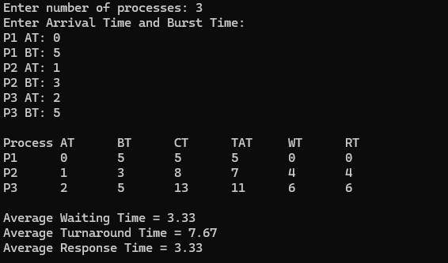

b) SJF(Preemptive):

#include <stdio.h>
#include <limits.h>

int main(){

int n,i,time=0,completed=0; int at[20], bt[20], rem_bt[20]; int ct[20], tat[20], wt[20], rt[20]; int first[20]={0};

float avg_wt=0, avg_tat=0, avg_rt=0;

printf("Enter number of processes: "); scanf("%d",&n);

printf("Enter Arrival Time and Burst Time:\n");

for(i=0;i<n;i++){ printf("P%d AT: ",i+1); scanf("%d",&at[i]);

printf("P%d BT: ",i+1); scanf("%d",&bt[i]);

rem_bt[i]=bt[i]; rt[i]=-1;
}

while(completed<n){

int shortest=-1;
int min_bt=INT_MAX;

for(i=0;i<n;i++){
if(at[i]<=time && rem_bt[i]>0 && rem_bt[i]<min_bt){ min_bt=rem_bt[i];
shortest=i;
}
}

if(shortest==-1){ time++; continue;
}

if(rt[shortest]==-1) rt[shortest]=time-at[shortest];

rem_bt[shortest]--; time++;

if(rem_bt[shortest]==0){ completed++;
ct[shortest]=time;

tat[shortest]=ct[shortest]-at[shortest]; wt[shortest]=tat[shortest]-bt[shortest];

avg_wt+=wt[shortest]; avg_tat+=tat[shortest]; avg_rt+=rt[shortest];
}
}

printf("\nProcess AT BT CT TAT WT RT\n");

for(i=0;i<n;i++){
printf("P%d %d %d %d %d %d %d\n", i+1,at[i],bt[i],ct[i],tat[i],wt[i],rt[i]);
}

printf("\nAverage Waiting Time = %.2f",avg_wt/n); printf("\nAverage Turnaround Time = %.2f",avg_tat/n); printf("\nAverage Response Time = %.2f\n",avg_rt/n);

return 0;
}

Output:

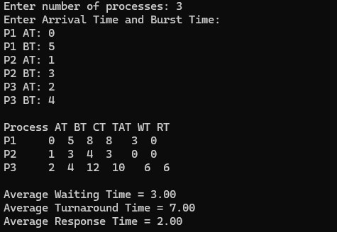

SJF (Non-Preemptive):

#include <stdio.h>
#include <limits.h>

int main() { int n, i, time = 0, completed = 0; int at[20], bt[20], ct[20], tat[20], wt[20], rt[20]; int done[20] = {0};

float avg_wt = 0, avg_tat = 0, avg_rt = 0;

printf("Enter number of processes: "); scanf("%d",&n);

printf("Enter Arrival Time and Burst Time:\n");

for(i=0;i<n;i++){ printf("P%d AT: ",i+1); scanf("%d",&at[i]);

printf("P%d BT: ",i+1); scanf("%d",&bt[i]);
}

while(completed < n){

int shortest = -1;
int min_bt = INT_MAX;

for(i=0;i<n;i++){
if(at[i] <= time && done[i]==0 && bt[i] < min_bt){ min_bt = bt[i];
shortest = i;
}
}

if(shortest == -1){ time++; continue;
}

rt[shortest] = time - at[shortest];

time += bt[shortest]; ct[shortest] = time;

tat[shortest] = ct[shortest] - at[shortest]; wt[shortest] = tat[shortest] - bt[shortest];

done[shortest] = 1; completed++;

avg_wt += wt[shortest]; avg_tat += tat[shortest];
avg_rt += rt[shortest];
}

printf("\nProcess AT BT CT TAT WT RT\n");

for(i=0;i<n;i++){
printf("P%d %d %d %d %d %d %d\n", i+1,at[i],bt[i],ct[i],tat[i],wt[i],rt[i]);
}

printf("\nAverage Waiting Time = %.2f",avg_wt/n);
printf("\nAverage Turnaround Time = %.2f",avg_tat/n); printf("\nAverage Response Time = %.2f\n",avg_rt/n);

return 0; }

Output:

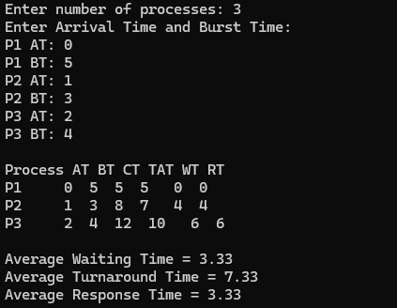

c) Priority(Preemptive):

#include <stdio.h>
#include <limits.h>

int main() { int n,i,time=0,completed=0; int at[20],bt[20],pr[20],rem_bt[20]; int ct[20],tat[20],wt[20],rt[20];

float avg_wt=0,avg_tat=0,avg_rt=0;

printf("Enter number of processes: "); scanf("%d",&n);

printf("Enter Arrival Time, Burst Time and Priority:\n");

for(i=0;i<n;i++)
{
printf("P%d AT: ",i+1); scanf("%d",&at[i]);

printf("P%d BT: ",i+1); scanf("%d",&bt[i]);

printf("P%d Priority: ",i+1); scanf("%d",&pr[i]);

rem_bt[i]=bt[i]; rt[i]=-1;
}

while(completed<n)
{
int highest=-1;
int min_pr=INT_MAX;

for(i=0;i<n;i++)
{
if(at[i]<=time && rem_bt[i]>0 && pr[i]<min_pr)
{ min_pr=pr[i]; highest=i;
}
}

if(highest==-1)
{ time++; continue;
}

if(rt[highest]==-1) rt[highest] = time - at[highest];

rem_bt[highest]--; time++; if(rem_bt[highest]==0)
{
completed++;

ct[highest]=time; tat[highest]=ct[highest]-at[highest]; wt[highest]=tat[highest]-bt[highest];

avg_wt+=wt[highest]; avg_tat+=tat[highest]; avg_rt+=rt[highest];
}
}

printf("\nProcess AT BT PR CT TAT WT RT\n");

for(i=0;i<n;i++)
{
printf("P%d %d %d %d %d %d %d %d\n", i+1,at[i],bt[i],pr[i],ct[i],tat[i],wt[i],rt[i]);
}

printf("\nAverage Waiting Time = %.2f",avg_wt/n); printf("\nAverage Turnaround Time = %.2f",avg_tat/n); printf("\nAverage Response Time = %.2f\n",avg_rt/n);

return 0; }

Output:
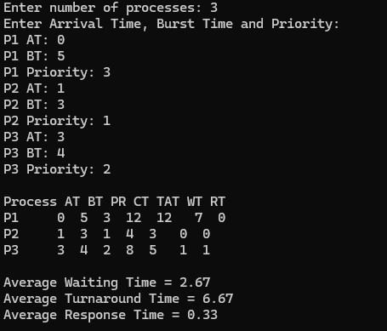
Priority (Non-preemptive):

#include <stdio.h>
#include <limits.h>

int main() { int n,i,time=0,completed=0;
int at[20],bt[20],pr[20];
int ct[20],tat[20],wt[20],rt[20]; int done[20]={0};

float avg_wt=0,avg_tat=0,avg_rt=0;

printf("Enter number of processes: "); scanf("%d",&n);

printf("Enter Arrival Time, Burst Time and Priority:\n");

for(i=0;i<n;i++)
{
printf("P%d AT: ",i+1); scanf("%d",&at[i]);

printf("P%d BT: ",i+1); scanf("%d",&bt[i]);

printf("P%d Priority: ",i+1); scanf("%d",&pr[i]);
}

while(completed<n)
{ int highest=-1; int min_pr=INT_MAX;

for(i=0;i<n;i++)
{
if(at[i]<=time && done[i]==0 && pr[i]<min_pr)
{ min_pr=pr[i]; highest=i;
}
}

if(highest==-1)
{ time++; continue;
}

rt[highest] = time - at[highest];

time += bt[highest]; ct[highest] = time;

tat[highest] = ct[highest] - at[highest]; wt[highest] = tat[highest] - bt[highest];

avg_wt += wt[highest]; avg_tat += tat[highest];
avg_rt += rt[highest];

done[highest]=1; completed++;
}

printf("\nProcess AT BT PR CT TAT WT RT\n");

for(i=0;i<n;i++)
{
printf("P%d %d %d %d %d %d %d %d\n", i+1,at[i],bt[i],pr[i],ct[i],tat[i],wt[i],rt[i]);
}

printf("\nAverage Waiting Time = %.2f",avg_wt/n); printf("\nAverage Turnaround Time = %.2f",avg_tat/n); printf("\nAverage Response Time = %.2f\n",avg_rt/n);

return 0;
}

Output:

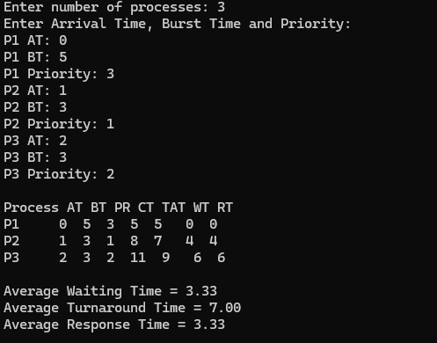

d) Round Robin:

#include <stdio.h>

void roundRobin(int n, int at[], int bt[], int tq) { int rt[n], ct[n], wt[n], tat[n], resp[n];

for (int i = 0; i < n; i++) { rt[i] = bt[i];
resp[i] = -1;
}

int time = 0, completed = 0;

while (completed < n) { int idle = 1;

for (int i = 0; i < n; i++) { if (at[i] <= time && rt[i] > 0) { idle = 0;

if (resp[i] == -1) { resp[i] = time - at[i];
}
if (rt[i] > tq) { time += tq; rt[i] -= tq; }
else {
time += rt[i]; ct[i] = time; rt[i] = 0; completed++;
}
}
}
if (idle) { time++;
}
}

float total_wt = 0, total_tat = 0, total_rt = 0;

for (int i = 0; i < n; i++) { tat[i] = ct[i] - at[i];
wt[i] = tat[i] - bt[i];

total_wt += wt[i]; total_tat += tat[i];
total_rt += resp[i];
}

printf("\nTime Quantum = %d\n", tq); printf("Process\tAT\tBT\tCT\tWT\tTAT\tRT\n");

for (int i = 0; i < n; i++) { printf("P%d\t%d\t%d\t%d\t%d\t%d\t%d\n",
i + 1, at[i], bt[i], ct[i], wt[i], tat[i], resp[i]);
}

printf("Average WT = %.2f\n", total_wt / n); printf("Average TAT = %.2f\n", total_tat / n);
printf("Average RT = %.2f\n", total_rt / n);
}

int main() { int n;

printf("Enter number of processes: "); scanf("%d", &n);

int at[n], bt[n];

for (int i = 0; i < n; i++) { printf("\nProcess P%d\n", i + 1);

printf("Arrival Time: "); scanf("%d", &at[i]);

printf("Burst Time: "); scanf("%d", &bt[i]);
}

int num_q, tq;

printf("\nEnter number of different Time Quantums: "); scanf("%d", &num_q);

for (int i = 0; i < num_q; i++) { printf("\nEnter Time Quantum %d: ", i + 1); scanf("%d", &tq);

roundRobin(n, at, bt, tq);
}

return 0;
}

Output:

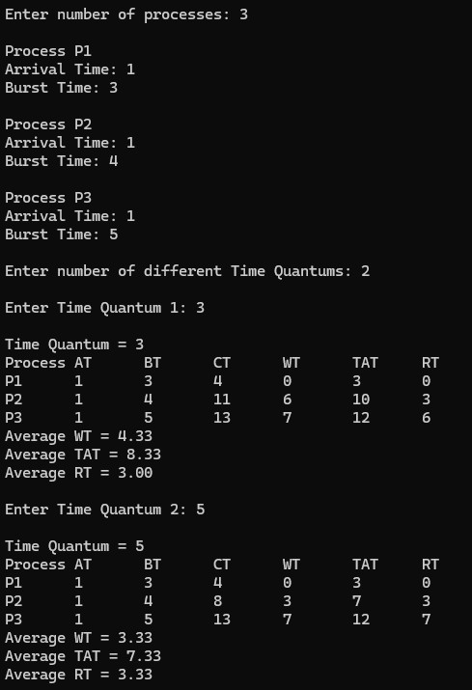

Lab Program 2:

Write a C program to simulate multi-level queue scheduling algorithm considering the following scenario.
All the processes in the system are divided into two categories – system processes and user processes. System processes are to be given higher priority than user processes. Use FCFS scheduling for the processes in each queue.

#include <stdio.h>
#include <string.h>
#define MAX_PROCESSES 100

typedef struct {
int process_id;
int arrival_time;
int burst_time;
int remaining_time; int type;
int completion_time; int waiting_time;
int turnaround_time; int started;
int start_time;
} Process;

typedef struct {
int items[MAX_PROCESSES];
int front, rear;
} Queue;

void initQueue(Queue* q) { q->front = 0;
q->rear = -1;
}

int isEmpty(Queue* q) { return q->rear < q->front;
}

void enqueue(Queue* q, int value) {
if (q->rear < MAX_PROCESSES - 1) { q->rear++;
q->items[q->rear] = value;
}
}

int dequeue(Queue* q) {
if (!isEmpty(q)) {
int val = q->items[q->front]; q->front++;
return val;
} return -1;
}

int compareArrival(const void* a, const void* b) {
Process* p1 = (Process*)a;
Process* p2 = (Process*)b;
if (p1->arrival_time < p2->arrival_time) return -1;
else if (p1->arrival_time > p2->arrival_time) return 1;
else
return 0;
}

int main() { int n;
Process processes[MAX_PROCESSES];

printf("Enter number of processes: "); scanf("%d", &n);

for (int i = 0; i < n; i++) { printf("\nProcess %d\n", i);
printf("Enter arrival time: ");
scanf("%d", &processes[i].arrival_time); printf("Enter burst time: ");
scanf("%d", &processes[i].burst_time); printf("Enter type (0 = System, 1 = User): "); scanf("%d", &processes[i].type);

processes[i].process_id = i; processes[i].remaining_time = processes[i].burst_time; processes[i].completion_time = 0; processes[i].waiting_time = 0; processes[i].turnaround_time = 0;
processes[i].started = 0;
processes[i].start_time = -1;
}

qsort(processes, n, sizeof(Process), compareArrival);

Queue systemQueue, userQueue; initQueue(&systemQueue); initQueue(&userQueue);

int completed = 0; int current_time = 0; int i = 0;
Process* current_process = NULL;

while (completed < n) { while (i < n && processes[i].arrival_time <= current_time) {
if (processes[i].type == 0)
enqueue(&systemQueue, i);
else
enqueue(&userQueue, i); i++;
}

if (current_process != NULL) {
if (current_process->type == 1 && !isEmpty(&systemQueue)) { enqueue(&userQueue, current_process - processes); current_process = NULL;
}
}

if (current_process == NULL) { if (!isEmpty(&systemQueue)) {
int idx = dequeue(&systemQueue); current_process = &processes[idx]; } else if (!isEmpty(&userQueue)) { int idx = dequeue(&userQueue); current_process = &processes[idx];
} else { current_time++; continue;
}
}

if (current_process->started == 0) {
current_process->start_time = current_time;
current_process->started = 1;
}

current_process->remaining_time--; current_time++;

if (current_process->remaining_time == 0) {
current_process->completion_time = current_time;
current_process->turnaround_time = current_process->completion_time - current_process-
>arrival_time;
current_process->waiting_time = current_process->turnaround_time - current_process->burst_time; completed++;
current_process = NULL;
}
}

printf("\nID\tType\tAT\tBT\tCT\tWT\tTAT\n"); double total_wt = 0, total_tat = 0; for (int j = 0; j < n; j++) { printf("%d\t%s\t%d\t%d\t%d\t%d\t%d\n", processes[j].process_id,
(processes[j].type == 0) ? "System" : "User", processes[j].arrival_time,
processes[j].burst_time, processes[j].completion_time, processes[j].waiting_time, processes[j].turnaround_time);

total_wt += processes[j].waiting_time; total_tat += processes[j].turnaround_time;
}

printf("\nAverage Waiting Time: %.2f\n", total_wt / n); printf("Average Turnaround Time: %.2f\n", total_tat / n);

return 0;
}
Output:

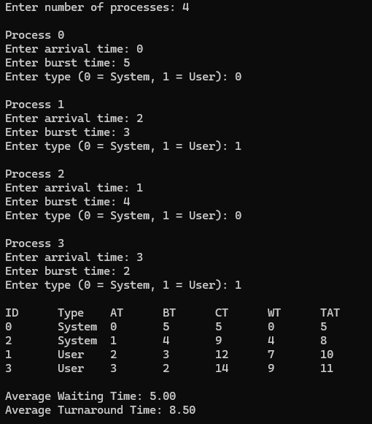

Lab Program 3:

Write a C program to simulate Real-Time CPU Scheduling algorithms:
a) Rate- Monotonic b) Earliest-deadline First c) Proportional scheduling

#include <stdio.h>
#include <math.h>

#define MAX 10

typedef struct { int id;
int burst;
int deadline; int period; int weight; int ct, wt, tat;
} Process;

void edf(Process p[], int n) { float util = 0;

for (int i = 0; i < n; i++)
util += (float)p[i].burst / p[i].deadline;

for (int i = 0; i < n - 1; i++)
for (int j = i + 1; j < n; j++)
if (p[i].deadline > p[j].deadline) { Process t = p[i]; p[i] = p[j]; p[j] = t;
}

int time = 0;
for (int i = 0; i < n; i++) { time += p[i].burst;
p[i].ct = time;
p[i].tat = p[i].ct;
p[i].wt = p[i].tat - p[i].burst;
}

printf("\n===== EDF Scheduling =====\n"); printf("Utilization = %.2f\n", util);
printf("Schedulable if U <= 1\n"); printf("ID\tBT\tDL\tCT\tWT\tTAT\n");
for (int i = 0; i < n; i++) printf("%d\t%d\t%d\t%d\t%d\t%d\n",
p[i].id, p[i].burst, p[i].deadline, p[i].ct, p[i].wt, p[i].tat);
}

void rms(Process p[], int n) { float util = 0;

for (int i = 0; i < n; i++)
util += (float)p[i].burst / p[i].period;

float bound = n * (pow(2, (float)1/n) - 1);

for (int i = 0; i < n - 1; i++)
for (int j = i + 1; j < n; j++)
if (p[i].period > p[j].period) { Process t = p[i]; p[i] = p[j]; p[j] = t;
}

int time = 0;
for (int i = 0; i < n; i++) { time += p[i].burst;
p[i].ct = time;
p[i].tat = p[i].ct;
p[i].wt = p[i].tat - p[i].burst;
}

printf("\n===== RMS Scheduling =====\n"); printf("Utilization = %.2f\n", util);
printf("RM Bound = %.4f\n", bound);

if (util <= bound) printf("Schedulable\n");
else
printf("Not guaranteed schedulable\n");

printf("ID\tBT\tPeriod\tCT\tWT\tTAT\n"); for (int i = 0; i < n; i++) printf("%d\t%d\t%d\t%d\t%d\t%d\n", p[i].id, p[i].burst, p[i].period, p[i].ct, p[i].wt, p[i].tat);
}

void proportional(Process p[], int n) { int total_weight = 0;

for (int i = 0; i < n; i++) total_weight += p[i].weight;

printf("\n===== Proportional Scheduling =====\n"); printf("Total Weight = %d\n", total_weight);

printf("ID\tWeight\tCPU Share\n");

for (int i = 0; i < n; i++) {
float share = (float)p[i].weight / total_weight; printf("%d\t%d\t%.2f\n", p[i].id, p[i].weight, share);
}
}

int main() { int n;
Process p1[MAX], p2[MAX], p3[MAX];

printf("Enter number of processes: "); scanf("%d", &n);

for (int i = 0; i < n; i++) { printf("\nProcess %d\n", i);

p1[i].id = p2[i].id = p3[i].id = i;

printf("Burst Time: "); scanf("%d", &p1[i].burst);

printf("Deadline (EDF): "); scanf("%d", &p1[i].deadline);

printf("Period (RMS): "); scanf("%d", &p1[i].period); printf("Weight (Proportional): "); scanf("%d", &p1[i].weight);

p2[i] = p1[i]; p3[i] = p1[i];
}

edf(p1, n); rms(p2, n); proportional(p3, n);

return 0;
}

Output:
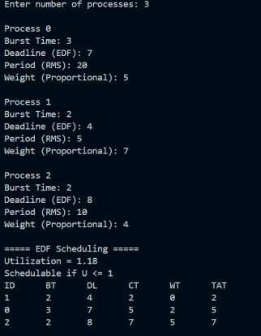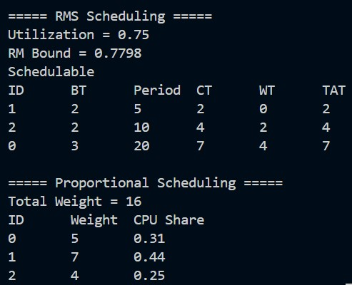

Lab Program 4:

Write a C program to simulate:
a) Producer-Consumer problem using semaphores b) Dining-Philosopher’s problem

a) Producer-Consumer problem using semaphores

#include <stdio.h>
#include <pthread.h>
#include <semaphore.h>
#include <unistd.h>

#define BUFFER_SIZE 5
#define ITEMS 15

int buffer[BUFFER_SIZE];
int in = 0, out = 0;

sem_t empty, full; pthread_mutex_t mutex;

void* producer(void* arg) {
for (int i = 0; i < ITEMS; i++) {

sem_wait(&empty); pthread_mutex_lock(&mutex);

buffer[in] = i;
printf("Produced: %d at buffer[%d]\n", i, in);

in = (in + 1) % BUFFER_SIZE;

pthread_mutex_unlock(&mutex); sem_post(&full);

usleep(100000);
}
return NULL;
}

void* consumer(void* arg) { for (int i = 0; i < ITEMS; i++) {

sem_wait(&full);
pthread_mutex_lock(&mutex);

int item = buffer[out];
printf("Consumed: %d from buffer[%d]\n", item, out);

out = (out + 1) % BUFFER_SIZE;

pthread_mutex_unlock(&mutex); sem_post(&empty);

usleep(150000);
}
return NULL;
}

int main() { pthread_t p, c;

sem_init(&empty, 0, BUFFER_SIZE);
sem_init(&full, 0, 0); pthread_mutex_init(&mutex, NULL);

pthread_create(&p, NULL, producer, NULL); pthread_create(&c, NULL, consumer, NULL);

pthread_join(p, NULL); pthread_join(c, NULL);

sem_destroy(&empty); sem_destroy(&full); pthread_mutex_destroy(&mutex);

return 0;
}

Output:
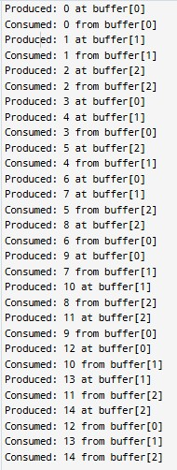

b) Dining-Philosopher’s problem

#include <stdio.h>
#include <pthread.h>
#include <semaphore.h>

#define N 5

sem_t forks[N];

void* philosopher(void* num) { int id = *(int*)num;

printf("Philosopher %d is thinking.\n", id);

// Deadlock prevention: last philosopher picks right first
if (id == N - 1) {
sem_wait(&forks[(id + 1) % N]); // right fork
printf("Philosopher %d picked up right fork %d.\n", id, (id + 1) % N);

sem_wait(&forks[id]); // left fork printf("Philosopher %d picked up left fork %d.\n", id, id); } else {
sem_wait(&forks[id]); // left fork
printf("Philosopher %d picked up left fork %d.\n", id, id);

sem_wait(&forks[(id + 1) % N]); // right fork printf("Philosopher %d picked up right fork %d.\n", id, (id + 1) % N);
}

printf("Philosopher %d is eating.\n", id);

sem_post(&forks[id]); sem_post(&forks[(id + 1) % N]);

printf("Philosopher %d put down forks %d and %d.\n", id, id, (id + 1) % N);

return NULL;
}

int main() { pthread_t phil[N]; int ids[N];

for (int i = 0; i < N; i++) { sem_init(&forks[i], 0, 1);
}

for (int i = 0; i < N; i++) { ids[i] = i;
pthread_create(&phil[i], NULL, philosopher, &ids[i]);
}

for (int i = 0; i < N; i++) { pthread_join(phil[i], NULL);
}

return 0;
}

Output:

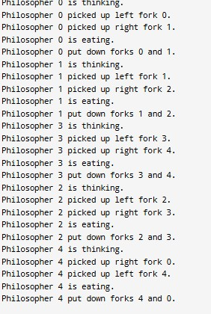

Lab Program 5:

Write a C program to simulate:
a) Bankers’ algorithm for the purpose of deadlock avoidance b) Deadlock Detection

a) Bankers’ algorithm for the purpose of deadlock avoidance

#include <stdio.h>

int main() { int n, m, i, j, k, ch;

printf("Enter no. of processes: "); scanf("%d", &n);

printf("Enter no. of resources: "); scanf("%d", &m);

int alloc[n][m], max[n][m], need[n][m]; int avail[m], work[m], finish[n], safe[n];

printf("Enter Allocation Matrix:\n"); for(i=0;i<n;i++)
for(j=0;j<m;j++) scanf("%d",&alloc[i][j]);

printf("Enter Max Matrix:\n"); for(i=0;i<n;i++) for(j=0;j<m;j++) scanf("%d",&max[i][j]);

printf("Enter Available Resources:\n"); for(i=0;i<m;i++) scanf("%d",&avail[i]);

for(i=0;i<n;i++) for(j=0;j<m;j++) need[i][j]=max[i][j]-alloc[i][j];

printf("\n1. Safety Algorithm"); printf("\n2. Resource Request"); printf("\nEnter choice(1 or 2): "); scanf("%d",&ch);

switch(ch) {

case 1: {
for(i=0;i<m;i++) work[i]=avail[i];
for(i=0;i<n;i++)
finish[i]=0;
int count=0;
while(count<n) {
int found=0;
for(i=0;i<n;i++) { if(finish[i]==0) { for(j=0;j<m;j++) if(need[i][j]>work[j]) break;
if(j==m) { for(k=0;k<m;k++) work[k]+=alloc[i][k]; safe[count++]=i; finish[i]=1;
found=1;
}
}
}
if(found==0) break;
}
if(count==n) {
printf("\nSAFE STATE\nSafe Sequence: "); for(i=0;i<n;i++)
printf("P%d ",safe[i]);
} else
printf("\nUNSAFE STATE");
break;
}

case 2: {
int p, req[m];
printf("Enter process number: "); scanf("%d",&p);
printf("Enter Request Vector:\n"); for(i=0;i<m;i++) for(i=0;i<m;i++) { if(req[i]>need[p][i]) { printf("Error: Exceeded Need"); return 0; } if(req[i]>avail[i]) { printf("Resources not available"); return 0;
}
}
for(i=0;i<m;i++) {
avail[i]-=req[i]; alloc[p][i]+=req[i];
need[p][i]-=req[i];
}
printf("\nRequest Granted\n"); break; }
default:
printf("Invalid Choice");
} return 0;
}

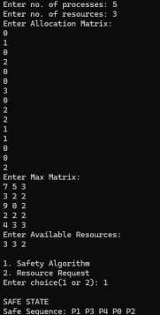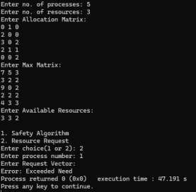
Output:

b) Deadlock Detection

#include <stdio.h>

int main() {
int n, m, i, j, k;

printf("Enter number of processes: "); scanf("%d", &n);

printf("Enter number of resource types: "); scanf("%d", &m);

int Allocation[n][m], Request[n][m]; int Available[m];

printf("\nEnter Allocation Matrix:\n"); for(i = 0; i < n; i++) {
for(j = 0; j < m; j++) { scanf("%d", &Allocation[i][j]);
}
}

printf("\nEnter Request Matrix:\n"); for(i = 0; i < n; i++) {
for(j = 0; j < m; j++) { scanf("%d", &Request[i][j]);
}
}

printf("\nEnter Available Resources:\n"); for(i = 0; i < m; i++) {
scanf("%d", &Available[i]);
}

int Work[m], Finish[n];

for(i = 0; i < m; i++) Work[i] = Available[i];

for(i = 0; i < n; i++)
Finish[i] = 0;

int count = 0;

while(count < n) {

int found = 0;

for(i = 0; i < n; i++) {

if(Finish[i] == 0) {

for(j = 0; j < m; j++) { if(Request[i][j] > Work[j]) break;
}
if(j == m){

for (k = 0; k < m; k++) { Work[k] += Allocation[i][k];
}

Finish[i] = 1;
found = 1; count++;
}
}
}

if(found == 0) break;
}

int deadlock = 0;

for(i = 0; i < n; i++) {
if(Finish[i] == 0) {
deadlock = 1;
printf("Process P%d is deadlocked.\n", i);
}
}

if(deadlock == 0)
printf("\nNo Deadlock Detected.\n");

return 0; }

Output:
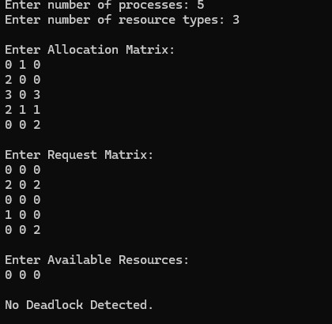

Lab Program 6:

Write a C program to simulate the following contiguous memory allocation techniques. a) Worst-fit b) Best-fit c) First-fit

#include <stdio.h>

int main() {
int nb, np, i, j;

printf("Enter number of memory blocks: "); scanf("%d", &nb);

int blockSize[nb];

printf("Enter sizes of %d memory blocks:\n", nb); for(i = 0; i < nb; i++) { scanf("%d", &blockSize[i]);
}

printf("Enter number of processes: "); scanf("%d", &np);

int process[np];

printf("Enter sizes of %d processes:\n",np); for(i = 0; i < np; i++) {
scanf("%d", &process[i]);
}

int firstFit[np], bestFit[np], worstFit[np];

for(i = 0; i < np; i++) { firstFit[i] = -1; bestFit[i] = -1; worstFit[i] = -1;
}

int used1[nb];

for(i = 0; i < nb; i++) used1[i] = 0;

for(i = 0; i < np; i++) {
for(j = 0; j < nb; j++) {
if(!used1[j] && blockSize[j] >= process[i]) {
firstFit[i] = j; used1[j] = 1; break;
}
}
}

int used2[nb];

for(i = 0; i < nb; i++) used2[i] = 0;

for(i = 0; i < np; i++) { int best = -1;

for(j = 0; j < nb; j++) {
if(!used2[j] && blockSize[j] >= process[i]) {

if(best == -1 || blockSize[j] < blockSize[best]) { best = j;
}
}
}

if(best != -1) { bestFit[i] = best; used2[best] = 1;
}
}

int used3[nb];

for(i = 0; i < nb; i++) used3[i] = 0;

for(i = 0; i < np; i++) { int worst = -1;

for(j = 0; j < nb; j++) {
if(!used3[j] && blockSize[j] >= process[i]) {

if(worst == -1 || blockSize[j] > blockSize[worst]) { worst = j;
}
}
}

if(worst != -1) { worstFit[i] = worst; used3[worst] = 1;
}
}

printf("\n--- First Fit ---\n");
printf("Process No.\tProcess Size\tBlock No.\n");

for(i = 0; i < np; i++) {
if(firstFit[i] != -1)
printf("%d\t\t%d\t\t%d\n", i + 1, process[i], firstFit[i] + 1); else
printf("%d\t\t%d\t\tNot Allocated\n", i + 1, process[i]);
}

printf("\n--- Best Fit ---\n");
printf("Process No.\tProcess Size\tBlock No.\n");

for(i = 0; i < np; i++) {
if(bestFit[i] != -1)
printf("%d\t\t%d\t\t%d\n", i + 1, process[i], bestFit[i] + 1); else
printf("%d\t\t%d\t\tNot Allocated\n", i + 1, process[i]);
}

printf("\n--- Worst Fit ---\n");
printf("Process No.\tProcess Size\tBlock No.\n");

for(i = 0; i < np; i++) {
if(worstFit[i] != -1)
printf("%d\t\t%d\t\t%d\n", i + 1, process[i], worstFit[i] + 1); else
printf("%d\t\t%d\t\tNot Allocated\n", i + 1, process[i]);
}

return 0; }

Output:

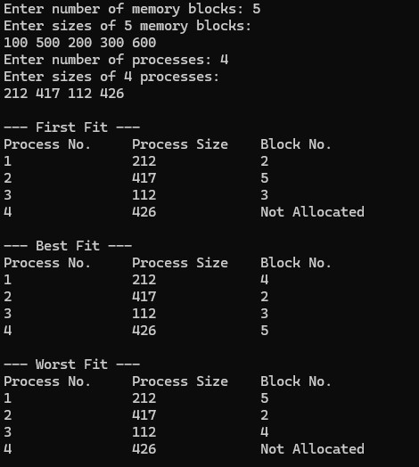

Lab Program 7:

Write a C program to simulate page replacement algorithms a) FIFO b) LRU c) Optimal

#include <stdio.h>

int fifo(int p[], int n, int f) {
int fr[10], i, j, k = 0, fault = 0, found;

for(i = 0; i < f; i++) fr[i] = -1;

for(i = 0; i < n; i++) { found = 0;
for(j = 0; j < f; j++) if(fr[j] == p[i]) found = 1;

if(!found) { fr[k] = p[i];
k = (k + 1) % f; fault++;
} } return fault;
}

int lru(int p[], int n, int f) {
int fr[10], time[10], i, j, pos, min, fault = 0;

for(i = 0; i < f; i++) {
fr[i] = -1;
time[i] = -1;
}

for(i = 0; i < n; i++) { int found = 0;
for(j = 0; j < f; j++) { if(fr[j] == p[i]) { found = 1; time[j] = i;
}
}

if(!found) { min = time[0]; pos = 0;

for(j = 1; j < f; j++) { if(time[j] < min) { min = time[j]; pos = j;
} } fr[pos] = p[i]; time[pos] = i; fault++;
} } return fault;
}

int optimal(int p[], int n, int f) {
int fr[10], i, j, k, pos, farthest, fault = 0;

for(i = 0; i < f; i++) fr[i] = -1;

for(i = 0; i < n; i++) { int found = 0;

for(j = 0; j < f; j++) { if(fr[j] == p[i]) { found = 1; break;
}
}

if(!found) { pos = -1; farthest = -1;

for(j = 0; j < f; j++) { int nextUse = -1; for(k = i + 1; k < n; k++) { if(fr[j] == p[k]) { nextUse = k; break;
}
}

if(nextUse == -1) {
pos = j; break;
}

if(nextUse > farthest) { farthest = nextUse; pos = j;
}
}
fr[pos] = p[i]; fault++;
}
}

return fault;
}

int main() {
int p[20], n, f, i;

printf("Enter number of pages: "); scanf("%d", &n);

printf("Enter pages: "); for(i = 0; i < n; i++) scanf("%d", &p[i]);

printf("Enter number of frames: "); scanf("%d", &f);
printf("\nFIFO Faults = %d", fifo(p, n, f)); printf("\nLRU Faults = %d", lru(p, n, f)); printf("\nOptimal Faults = %d", optimal(p, n, f));
}
Output:

